**Advanced Programming Lab 7**

**Submitted By: Daud Nasir Cheema (209563)**

**Task 1:**

**server.js:**

var express = require('express');

var app = express();

path = require('path');

var bodyParser = require('body-parser');

var urlencodedParser = bodyParser.urlencoded({ extended: false })

app.set('view engine', 'pug');

app.set('views','./views');

app.get('/', function (req, res) {

res.sendFile(path.join(__dirname+'/index.html'));

})

app.post('/submit', urlencodedParser, function (req, res) {

response = {

firstname:req.body.firstname,

lastname:req.body.lastname

};

console.log(response);

res.write("Your first name: "+response.firstname);

res.write("\nYour last name: "+response.lastname);

res.end();

})

app.get('/first_template', function(req, res){

res.render('first_view');

});

var server = app.listen(8081, function () {

var host = server.address().address

var port = server.address().port

console.log("Example app listening at http://%s:%s", host, port)

})

**index.html**

<html>

<head>

<title>Hi!</title>

</head>

<body>

<form action="/submit" method="post">

First name:<br>

<input type="text" name="firstname"><br>

Last name:<br>

<input type="text" name="lastname"><br><br>

<input type="submit" value="Submit">

</form>

</body>

</html>

**Output:**

Submitting form:

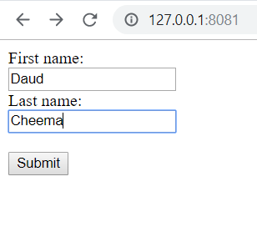

Form submitted:

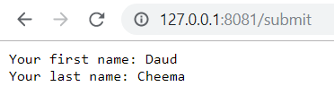

**Task 2:**

**task2.js**

var express = require('express');

var app = express();

path = require('path');

var bodyParser = require('body-parser');

var multer = require('multer');

var mlt = multer();

//var urlencodedParser = bodyParser.urlencoded({ extended: false })

app.set('view engine', 'pug');

app.set('views','./views');

app.get('/', function (req, res) {

res.sendFile(path.join(__dirname+'/fileupload.html'));

})

app.post('/uploadF', mlt.single("myfile"), function (req, res) {

file = req.file;

if (!file)

{

res.write("File upload error");

}

else

{

res.write("File uploaded");

}

res.end();

})

app.get('/first_template', function(req, res){

res.render('first_view');

});

var server = app.listen(8081, function () {

var host = server.address().address

var port = server.address().port

console.log("Example app listening at http://%s:%s", host, port)

})

**fileupload.html**

**Output:**

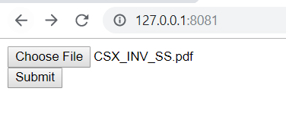

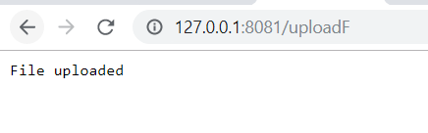

**Task 3:**

**task3.js:**

var express = require('express');

var app = express();

path = require('path');

var bodyParser = require('body-parser');

var urlencodedParser = bodyParser.urlencoded({ extended: false })

app.set('view engine', 'pug');

app.set('views','./views');

app.get('/', function (req, res) {

res.render('form');

})

app.post('/submit', urlencodedParser, function (req, res) {

response = {

firstname:req.body.firstname,

lastname:req.body.lastname

};

console.log(response);

res.write("Your first name: "+response.firstname);

res.write("\nYour last name: "+response.lastname);

res.end();

})

app.get('/first_template', function(req, res){

res.render('first_view');

});

var server = app.listen(8081, function () {

var host = server.address().address

var port = server.address().port

console.log("Example app listening at http://%s:%s", host, port)

})

**form.pug:**

doctype html

html

head

title My Form

body

form(action="/submit" method="POST")

label First Name:

input(type="text", name="firstname")

br

br

label Last Name:

input(type="text", name="lastname")

br

br

input(type="submit", value="submit")

**Output:**

